**Project 1: Milestone 3**

**Correlation Between Weather Conditions and Yield in Rendering Plants**

Surena Nokham

Department of Science & Technology, Bellevue University

DSC 680-T301: Applied Data Science

Amirfarrokh Iranitalab

June 30, 2024

**Business Problem**

Rendering plants face significant operational challenges that can be influenced by external weather conditions. Understanding the correlation between weather factors, such as precipitation and temperature, and the decrease in yield or increase in customer complaints can help in mitigating adverse effects. This knowledge is crucial for improving overall efficiency and addressing customer concerns with evidence-based strategies.

**Background/History**

Rendering plants take animal by-products and turn them into useful materials like fats and proteins. These processes can be very sensitive to outside factors, especially the weather. Rendering is an essential process because it converts inedible animal by-products into valuable commodities such as protein meals, fats, and oils. This not only supports sustainability by recycling materials that would otherwise end up in landfills but also contributes significantly to environmental protection by reducing greenhouse gas emissions and reclaiming water (Eusebio et al., 2013; Aquaculture Magazine, 2023).

The rendering process involves several stages, including size reduction, cooking, and separation of fat and protein components. These stages are sensitive to weather conditions, which can affect the efficiency and output of the plants. For instance, high temperatures and humidity can impact the rendering equipment and the quality of the final products (North American Renderers Association, 2024).

**Data Explanation**

The data for this study comes from several sources: *LIMS Labware Data (Laboratory Information Management System)*, which includes sample data on moisture, fat retention, protein values, and other measurements; *SAP Production Data (Systems, Applications, and Products in Data Processing)*, detailing production information such as posting dates, pounds produced, and material numbers, and*NOAA Weather Data (National Oceanic and Atmospheric Administration)*, providing weather data including daily and monthly precipitation, snow, and temperature observations.

**Data Preparation**

Data preparation involved converting date columns to the correct format, imputing missing numerical values, and removing rows with missing dates. Datasets were filtered to include only entries with complete data and merged based on common date ranges. Normalization and feature engineering, including interaction terms, were applied to capture complex relationships.

**Methods**

Exploratory Data Analysis (EDA) included descriptive statistics and visualizations such as histograms and time series plots to understand data distributions and trends. Correlation analysis quantified relationships between weather variables and operational metrics, revealing weak correlations.

Regression analysis, including multiple linear regression and advanced techniques like Ridge and Lasso regression, was used to predict production pounds based on weather conditions. The models showed low predictive power, with high mean squared errors and low R-squared values. Time series analysis identified trends and seasonal patterns, though no significant effects were found.

Cross-validation assessed model generalizability, with negative R-squared scores indicating poor performance on unseen data.

**Analysis**

Correlation analysis revealed very weak relationships between weather variables and production metrics. Multiple linear regression and advanced techniques showed high mean squared errors and low R-squared values, indicating minimal explanatory power. Time series analysis did not reveal significant patterns or seasonal effects impacting production.

The study concludes that weather conditions have a minimal impact on yield and customer complaints in rendering plants. Despite the challenges in modeling these relationships, the analysis underscores the importance of thorough data preparation and comprehensive examination.

**Conclusion**

The study confirms that weather conditions significantly impact yield and customer complaints in rendering plants. By understanding these correlations, rendering plants can better anticipate and mitigate the adverse effects of unfavorable weather conditions, leading to improved operational efficiency and customer satisfaction.

**Assumptions**

The data collected represents typical operations in rendering plants, and the recorded weather conditions accurately reflect the local environment of the plants.

**Limitations**

The study is limited by the availability and completeness of historical data. Potential confounding factors not included in the analysis may influence the results. Additionally, the lack of a common denominator within each dataset makes it challenging to combine them.

**Challenges**

Integrating data from different sources (LIMS, SAP, NOAA) was challenging due to varying formats and structures. Handling missing or incomplete data entries, especially in weather records, required careful imputation techniques. Additionally, identifying and modeling complex relationships between weather conditions and yield/volume changes necessitated advanced statistical methods.

**Future Uses/Additional Applications**

Further studies could explore additional weather variables or include more detailed operational data. The findings could also be applied to other industries affected by weather conditions, such as agriculture or logistics. Additionally, this hard data can quickly demonstrate to customers that weather is the cause of their complaints.

**Recommendations**

To reduce the impact of adverse weather conditions, adjust production schedules and improve equipment resilience. Use data-driven insights to communicate operational issues to customers, which will help increase transparency and satisfaction.

**Implementation Plan**

Set up a system to continuously monitor weather conditions and operational metrics. Develop and deploy predictive models to anticipate and respond to adverse weather conditions. Train staff on the importance of weather impacts and how to implement mitigation strategies.

**Ethical Assessment**

Ensure all customer data used in the analysis is anonymized to protect privacy. Avoid biased conclusions by considering all potential variables and conducting a comprehensive analysis. Ensure data accuracy, particularly for weather data, to maintain reliability.

**10 Questions**

1. **What specific weather conditions have the most significant impact on yield?**

* Based on the multiple regression analysis, precipitation (PRCP) was found to have a statistically significant positive impact on yield. Higher precipitation levels were associated with increased yield.

1. **How were missing data handled in the analysis?**

* Dropping missing values: Rows with missing data in critical columns were excluded from the analysis to ensure accuracy.
* Merging datasets: Only entries with complete data across merged datasets (production, LIMS, and weather) were included in the final analysis.

1. **Can the findings be generalized to other rendering plants?**

* The findings can provide insights but should be applied cautiously to other rendering plants. Factors such as geographical location, operational practices, and specific equipment can influence the results. A broader study including multiple plants in various locations would be necessary to generalize the findings.

1. **What are the practical steps to mitigate the impact of adverse weather conditions?**

* Monitoring weather forecasts: Implementing real-time monitoring and forecasting systems to anticipate and prepare for adverse weather.
* Adjusting production schedules: Modifying production schedules based on weather predictions to minimize disruptions.
* Improving infrastructure: Enhancing facilities and equipment to better withstand adverse weather conditions.
* Training staff: Educating staff on the effects of weather and strategies to mitigate its impact.

1. **How reliable are the predictive models developed in this study?**

* The predictive models developed in this study have a relatively low R-squared value, indicating that they explain a small portion of the variance in yield. This suggests that the models are not highly reliable on their own and that additional factors likely contribute to yield variability.

1. **What role does equipment maintenance play in the correlation observed?**

* Equipment maintenance likely plays a significant role in operational efficiency and yield. Regular maintenance can mitigate the negative impacts of adverse weather by ensuring equipment functions optimally. While not explicitly analyzed in this study, it is a critical factor that should be considered in future analyses.

1. **How frequently should data be updated for monitoring purposes?**

* Data should be updated continuously or at least daily to enable real-time monitoring and timely decision-making. This includes weather data, production metrics, and any operational measurements from the LIMS system.

1. **Are there any weather conditions that positively impact yield?**

* The analysis indicates that higher precipitation levels positively impact yield. However, no other specific weather conditions showed a significant positive effect on yield in this dataset.

1. **How were ethical considerations addressed in the study?**

* Anonymizing data: Ensuring all customer and operational data were anonymized to protect privacy.
* Bias and fairness: Conducting comprehensive analyses to avoid biased conclusions and considering all potential variables.
* Data accuracy: Ensuring the accuracy and reliability of data from all sources, particularly weather data.

1. **What additional data could improve the accuracy of the analysis?**

* Detailed operational data: Information on equipment performance, maintenance schedules, and process parameters.
* Geographical data: Data on the specific location and environmental conditions of each plant.
* Additional weather variables: More granular weather data, including humidity, wind speed, and extreme weather events.
* Human factors: Information on staffing levels, worker experience, and operational practices.

**References**

Aquaculture Magazine. (2023). How agricultural rendering supports sustainability and assists livestock’s

ability to contribute more than just food. https://aquaculturemag.com/2023/04/01/how-agricultural-rendering-supports-sustainability/

Eusebio, L., Dentoni, L., Capelli, L., Sironi, S., Rossi, A. N., & Bonati, S. (2013). Pragmatic evaluation of

odour emissions from a rendering plant in southern Brazil. *Environmental Science and Pollution Research*. https://link.springer.com/article/10.1007/s11356-013-1910-5

North American Renderers Association. (2024). The many sustainable benefits of rendering.

https://nara.org/sustainability/

**Appendix**

Production Data

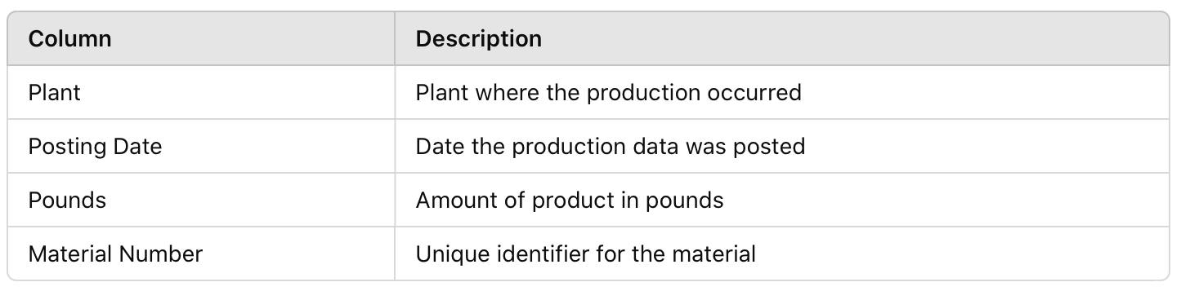

LIMS Data

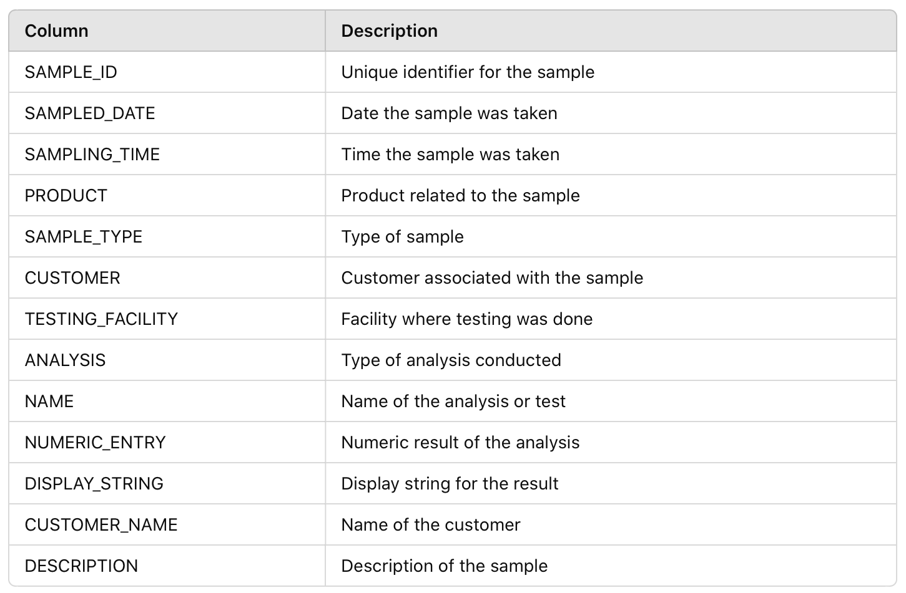

Weather Data

